- 
- Please show me from where I can change the images because they are placed the other way around
- Please provide a link with a tutorial and acces from where I can make changes backend for the home page,client and admin dashboard, for email and everything regarding the platform.

2.. /index.html and /landing.html are empty from an SEO perspective
Both pages contain only JavaScript auth-check — no <h1>, <h2>, or visible HTML content in the raw source. The page is built dynamically via React on the client side. Google will index an empty page — SEO score is currently zero.
Fix: Add proper meta tags + fallback HTML for SEO (SSR or static prerender the homepage).

2. /cookies.html is broken
Currently shows "Redirecting to Cookie Policy..." and never actually redirects anywhere. It's stuck.
Fix: Either point it to the actual cookie policy content or fix the redirect target.

3. Four /use-case/* pages are generic AI startup template placeholders — completely unrelated to tyes
All four pages contain content copied from a generic AI startup template. None of it has anything to do with tyes (beauty / campaign visuals / brand strategy):
URL | Current content | Action
/use-case/beyond.html | "AI-Enhanced Supply Chain Optimization" | DELETE
/use-case/healthify.html | "Predictive Analytics for Healthcare Management" | DELETE
/use-case/fintechpro.html | "AI-Driven Fraud Detection System" | DELETE
/use-case/innovatex.html | "AI-Powered Product Recommendation Engine (e-commerce)" | DELETE
These pages must be deleted entirely — not replaced with new content, just removed. They're template leftovers.
Also on the homepage — in the "AI in Action: Use Cases" section — the images currently link to these placeholder pages. Please update the section so the images are display-only (no click, no link, no navigation). Just visual examples of what we deliver. If we want case studies later, we'll add real ones.
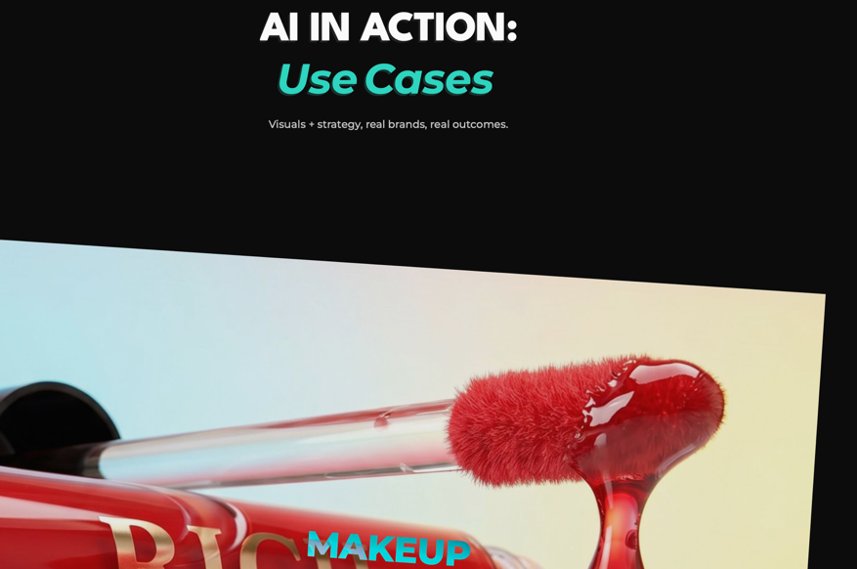
- Also remove the words USE CASES, leave only AI IN ACTION

4. Remove .html from all URLs
Clean URLs are the modern standard. tyes.app/pricing is much better than tyes.app/pricing.html for SEO, sharing, and brand perception.
How to implement:
- If on Vercel: add "cleanUrls": true to vercel.json
- Add 301 permanent redirects from /pricing.html → /pricing so we don't get duplicate content penalties
- Update all internal links in HTML/React from href="pricing.html" to href="/pricing"
- Update sitemap.xml and canonical tags

